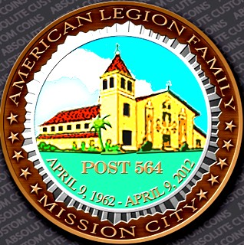

Post 564
-

Mission City

News Bulletin

Santa Clara CA

Chartered 9 April
1962

August 2025 Issue

Mission City Post #564 Dues have gone up to #55.00,
At the AML state Convention Department, this last June voted on raising
The dues, has nothing to do with the Post. We just follow what they charge


From The Commanders Desk
Hello. We hope everyone is enjoying their summer. This month Ron and I have been working on cleaning and making repairs to the bar to get it through inspection. We hope to have it back up and open soon. From here we will be making more repairs on the building.
We are also still looking for anyone willing to give some time and help out with any number of things that need attention. Anyone that has an interest in being on the
building foundation or charities board can let us know at any of the post meetings. As a
reminder, our meeting will be Aug 22nd with dinner from 6:00-7:00. Meeting will be at 7:00. I look forward to seeing you then

Antonio Guida, Post Commander

From the Office of 2nd Vice
Hello American Legion Post 564,
Happy August 2025, I hope that this Summer has gone well, and as we get ready for the Autumn season it will be excellent also. I have been elected into the Second Vice position for this upcoming 2025-2026 year with our Post 564 and will serve you all to the best of my abilities for our American Legion Organization. Currently I am with the American Legion Riders as well, so if any one is interested please reach out for information about some Motorcycling. We should have another tremendous year in front of us all, and together make it as awesome as all our previous years at the Post 564 have been. Looking forward to meeting all Members, Sons, Auxiliary, and District 13 Riders in the upcoming months at our monthly dinners and meetings. Have an excellent start to the school year for all the Students out there. As this year is flying by please try your best to participate with us and join our events. Your Membership and interests are what keeps us moving forward as a Veteran's Service Organization.
Respectfully,
Jimshed Akhtar, Second Vice Commander Post 564/ American Legion Riders District 13
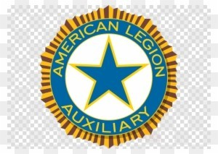
Let's Congratulate Susan Baker as our new Department President and Tracy Varnell Fercho our new Department Vice President on their new roles ,It's great to hear about the hard work these ladies are putting in. Now the Department Convention is done , let's proceed to our Unit business.
Also let's Congratulate our Unit President Donita Faktesek.
Please join us for our next membership meeting on Thursday, August 22nd, at 8:00 PM. We'll be discussing our goals for the upcoming year, and your input is vital. We also need to vote for Unit officers; Treasurer , Chaplain , Sgt @ Arms .
You can attend either in person or via Zoom. We look forward to seeing you there!
Hat's Off to the Veterans
Sincerely ,
Cece Harvey 1st Vice President - Unit 564
American Legion Auxiliary Ladies of Unit 564,
Welcome to the new year! Convention was a success and now is the time to begin our new year. Beginning with paying your dues. You can do this online now and as soon as it is recorded the membership chairman should be sending you your dues card.
We have had a difficult year, but we are hoping with the new year, more members will be able to come to meetings. even if it's by Zoom. Zoom is a great way to have an evening meeting and maybe plan day activities together.
Remember each member Is very important and we can only become a viable Unit with all of us working together. We hope this new year we can bring strength. Love. and give support to our Veterans. Our Veterans look forward to our support. Many have no one else so can you be a supporter?
In love and ALA Courage,
jan
Jan McCormick. Past President and Executive Woman
Business meetings are every fourth week of the month (except in November) at a new time, 7:00 pm. Changes will be made to the Standing Rules!
Mission City August Dates of Interest

August 22nd
5:00 Exec. Meeting
6:00 Dinner
7:00 AML Meeting
See You There

August Dates in History
Hamilton, the Secretary of the Treasury at the time

American military decoration for military merit and those who have been wounded or killed in military service
August 14: End of World War with Japan announced in 1945, and
National Navajo Code Talkers Day
August 16: National Airborne Day honors the nation's airborne forces
August 29: Marine Corps Reserve Birthday, established in 1916 by
President Woodrow
Wilson when demand for warfighters increased during World War I
RENTALS AVAILABLE Do you have an event in the near future? We can accommodate your Rental Needs. Our Banquet Hall, Pavilion, and Gazebo are available throughout the year! We give discounts to members, school organizations, and charities.
For more information: Commander Tony: 408-761-0673

